**UT01536**

**Car Rental Management System**

Landing page for Users "X:\CAR-RENTAL-UT01536\home.html"  
Admin Page "X:\CAR-RENTAL-UT01536\admin-login.html"

The Car Rental Management System is a web-based application designed to streamline and manage the daily operations of a car rental store. Built using JavaScript, HTML, and CSS, this system provides a comprehensive platform for store managers to efficiently manage cars, categorize the fleet, and oversee member activities. The primary goal of this project is to enhance the functionality of traditional rental stores by leveraging modern web technologies to deliver a user-friendly and effective management tool.

**Key Features**

# 1. Car Management by Manager

* **Add or Remove Cars :** Managers have the authority to add new cars to the store's inventory or remove existing ones. This feature ensures that the store's fleet is always up-to-date and relevant.
* **Categorize Cars :** Cars can be categorized based on various criteria such as type, brand, model year, and more. This categorization aids in easy navigation and retrieval of cars by both managers and customers.

# 2. Inventory Management

* **Unique Identification :** Each car is identified by its unique vehicle registration number. This ensures precise tracking and management of the fleet.
* **Multiple Units :** The system supports the addition of multiple units of the same car model. This feature is crucial for stores that need to manage large volumes of cars and ensure that multiple customers can rent the same model simultaneously.

# 3. Customer Registration and Management

* **NIC Number Registration :** Customers are required to register with their National Identity Card (NIC) number. This ensures a unique identifier for each customer, simplifying the process of tracking rental history and managing customer information.
* **User Profile Management :** Customers can view and update their personal information, check their rental history, and see the status of cars they have rented.

# 4. Car Renting and Return

* **Renting Cars :** Customers can rent cars for a specified period, such as a few hours or days. The system keeps track of the rental date and time and automatically calculates the due time.
* **Overdue Alerts :** If a customer fails to return a car within the specified period, the system generates an alert for the manager. This feature ensures that cars are returned on time and helps maintain the store’s inventory.

**BRD Edited : if a customer take a car for 5 days and he is in long distance from our company but his trip or work is not completed in 5 days so he can use continuedly and it will be profit for our company. So not create overdue aleart.**

* **Return Processing :** When a customer returns a car, the system updates the rental section to reflect the return. This includes marking the car as available for renting again and removing it from the customer’s active rented cars list.
* **BRD Edited** : **Customers can’t return Cars only return after admin Verified**

# 5. Reports

* **Inventory Report** : Provides a detailed overview of all cars in the store, including their categories and availability.
* **Rental Report :** Tracks the rental history, overdue cars, and frequently rented cars.
* **Customer Report :** Lists all registered customers and their rental activities.

**User Roles**

# 1. Manager

* Manage cars (add, remove, categorize).
* View and manage customer information.
* Oversee renting and return processes. - Generate and view reports.

# 2. Customer

* Register and manage their profile.
* Rent and return(BRD Edited) cars.
* View rental history and status of rented cars.

# Technical Overview

The Car Rental Management System is developed using a combination of JavaScript, HTML, and CSS. To ensure simplicity and ease of use, the system is designed to work entirely on the client side, utilizing local storage for data persistence. This approach eliminates the need for a server-side backend, making it ideal for small to medium-sized rental stores.

* **JavaScript :** Manages the core functionality, including event handling, DOM manipulation, and interaction with local storage. JavaScript is used to perform all operations such as adding/removing cars, updating categories, and managing customer data.
* **HTML :** Structures the content and elements of the web pages.
* **CSS :** Enhances the appearance and layout, providing a consistent and user-friendly design across different devices and screen sizes.
* **Local Storage :** Utilized for data persistence, local storage ensures that all data (cars, customers, rental records) is saved directly in the user's browser. This enables the application to retain data between sessions without requiring a server-side database.

# Conclusion

The Car Rental Management System offers a robust solution for managing the diverse needs of a car rental store. By integrating essential features such as car management, customer registration, and rental processes, it simplifies the day-to-day operations for managers while providing a seamless experience for customers. The addition of comprehensive reporting capabilities enhances the system's utility by providing valuable insights into inventory, rental trends, and customer activities. This project represents a significant step towards digitizing rental management and improving the overall efficiency and accessibility of rental services.

Welcome to the realistic Car rental Service Experience!

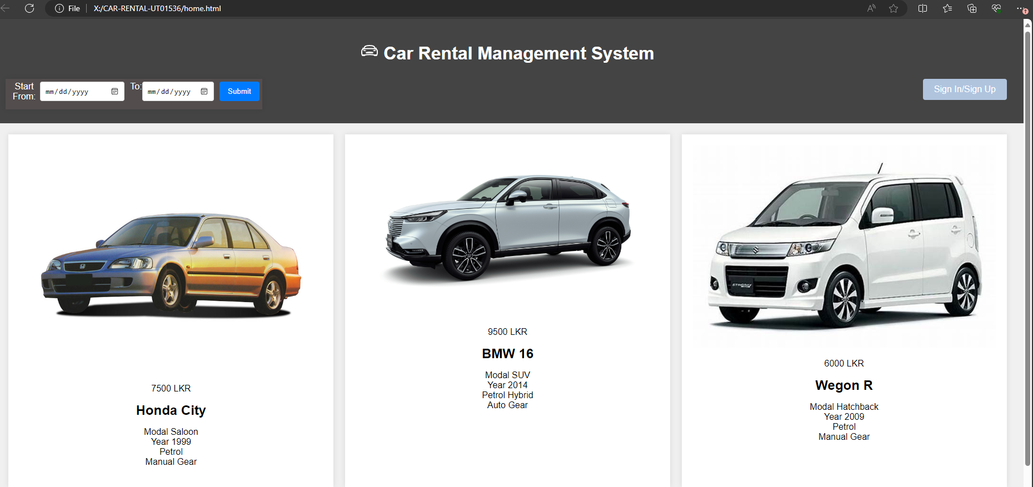

This is landing / index/ home page for available in online and anyone can view. Date Search function now available for this time

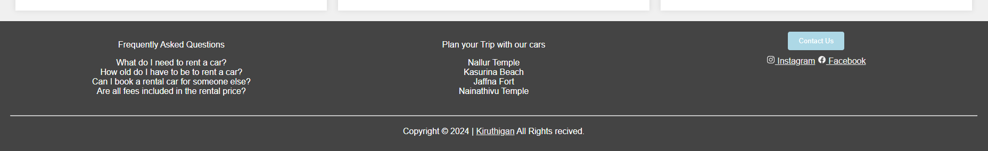

This is footer part of this page.

404! Contact button not connect until now.

So click on Signup/Sign in Button.

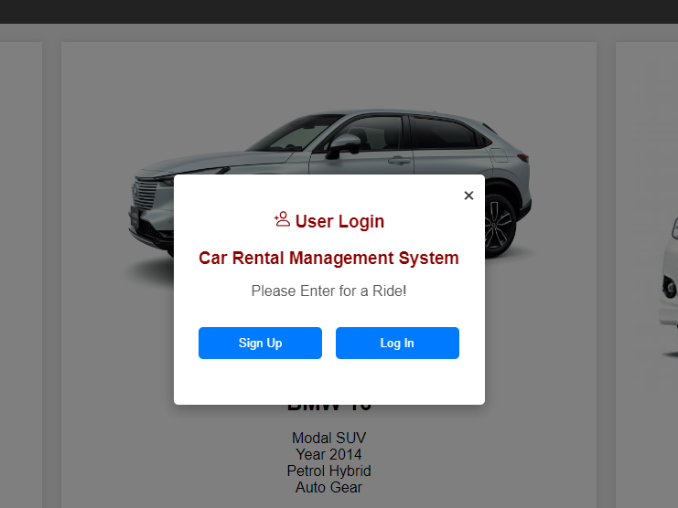

If click sign up

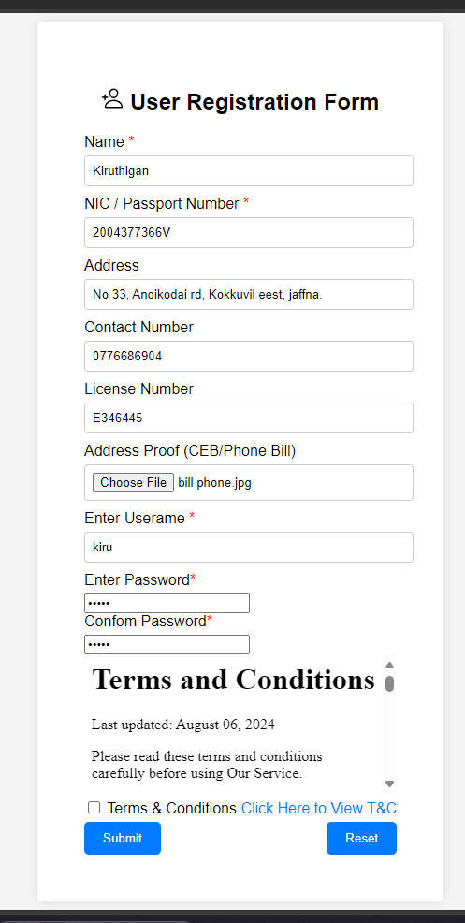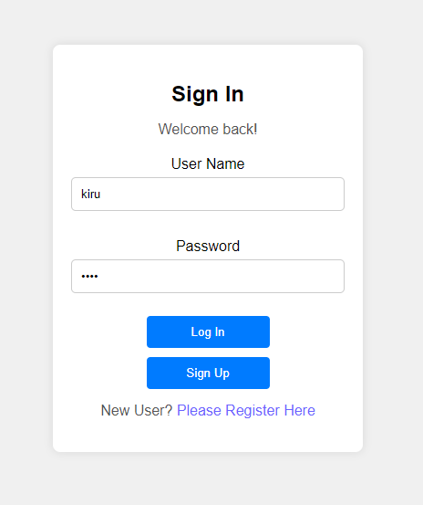view and Click the T & C tic then submit. Data will saved in local storage.

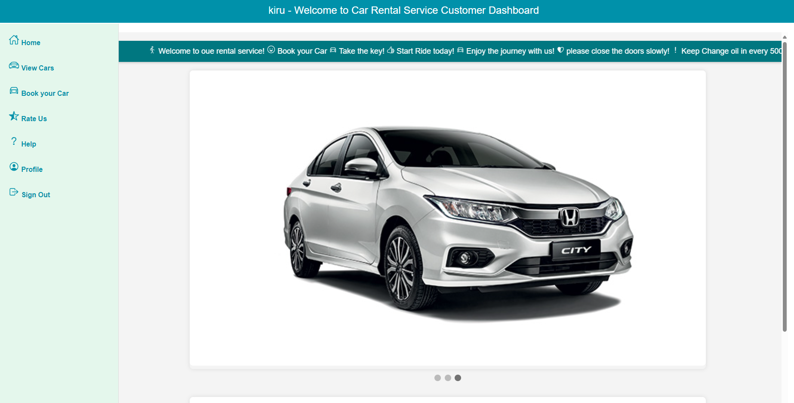 Customer Dashboard!

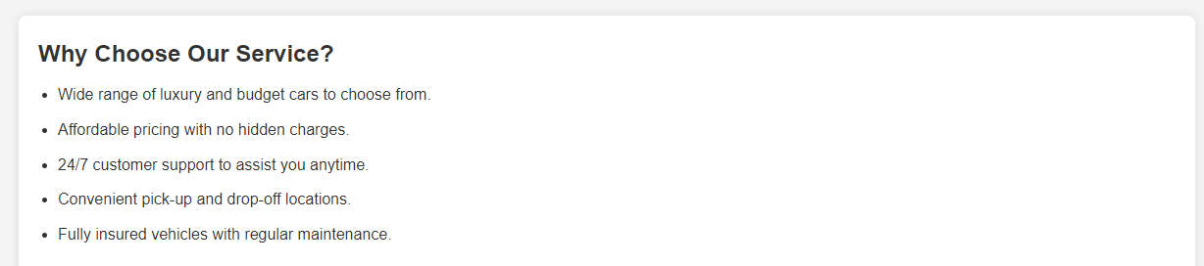

Customer dashboard footer.

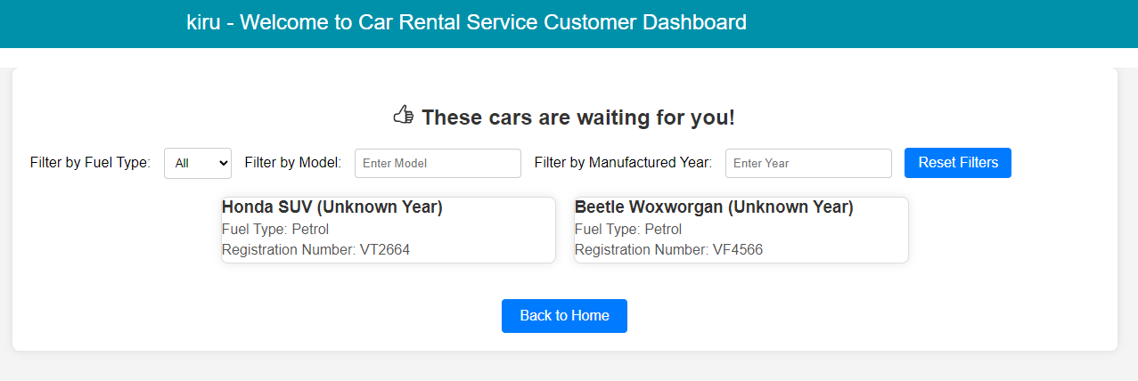

Available Cars for customer.

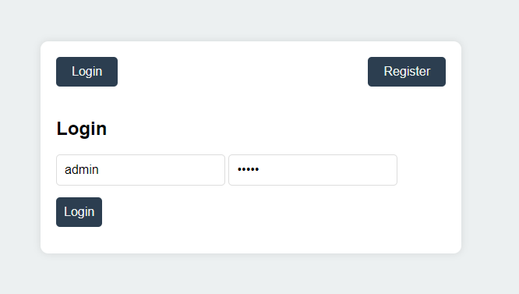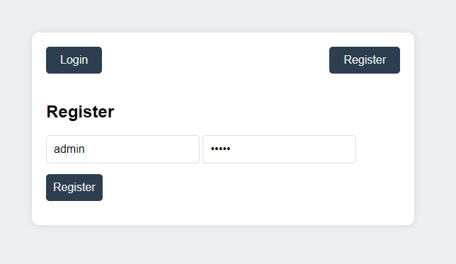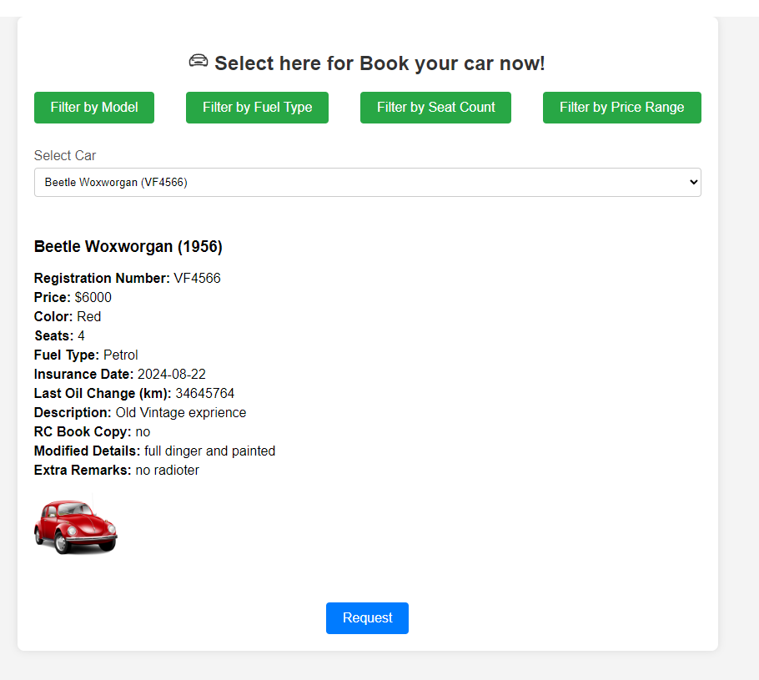

Book Your car!

The request will be sent to admin notification panel.

Admin can register and login to enter admin dashboard

"X:\CAR-RENTAL-UT01536\admin-dashboard.html" **or go this location.**

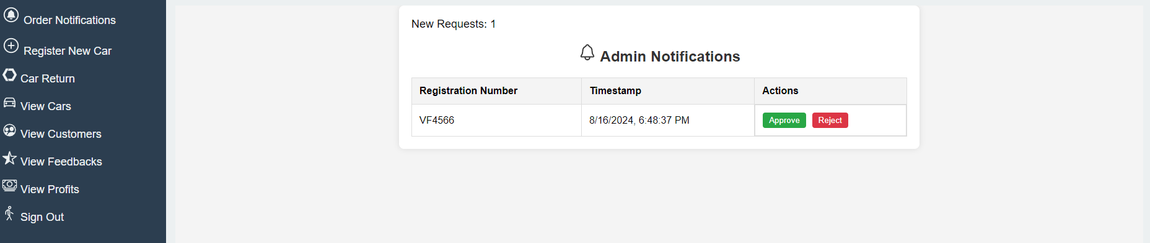

Admin can Approve or Reject the Rental request.

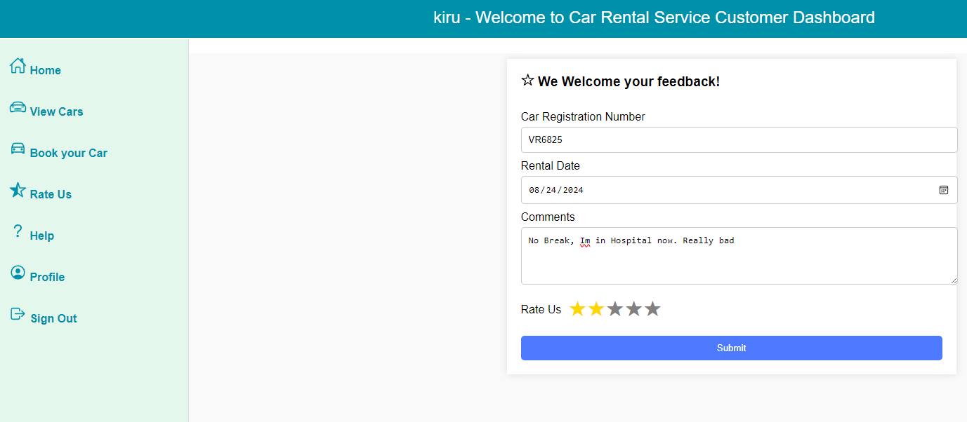

Customer can share their experience. And admin can view it.

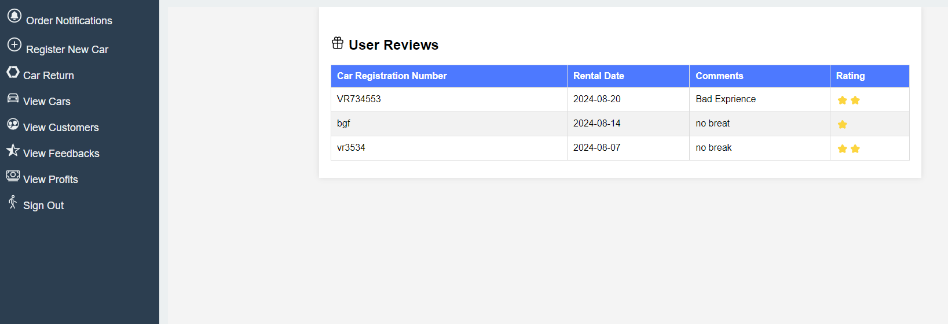

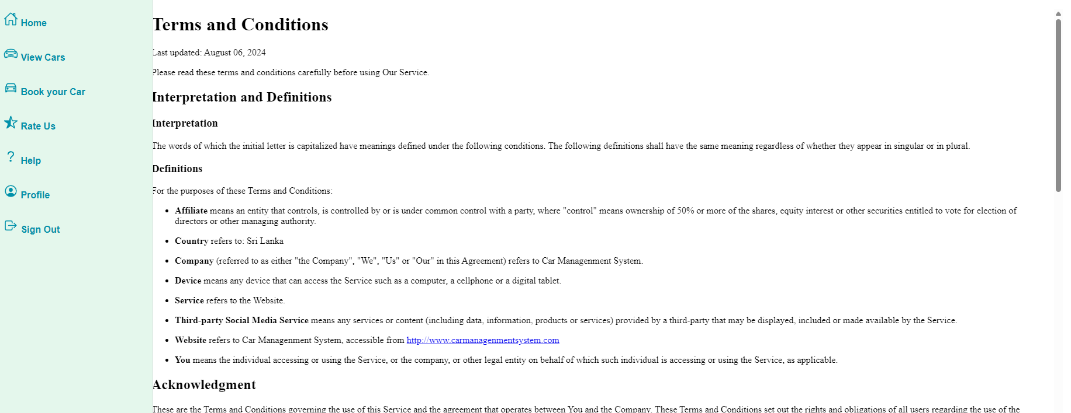

Car Rental agreement and help notes for clients.

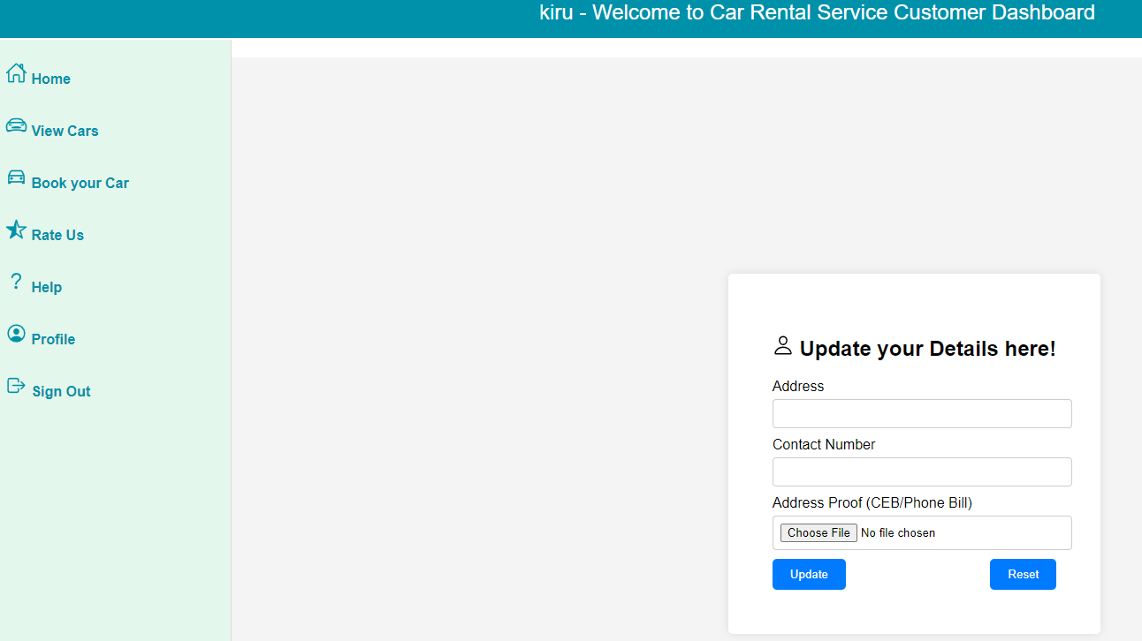

Users Can Update their profile without Name, NIC/Passport Number and license Number. Only can update address proof and address, add Secondary Phone number.

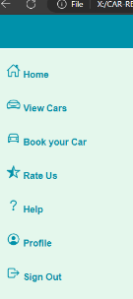

If user click on sign out the page will redirect to home page.

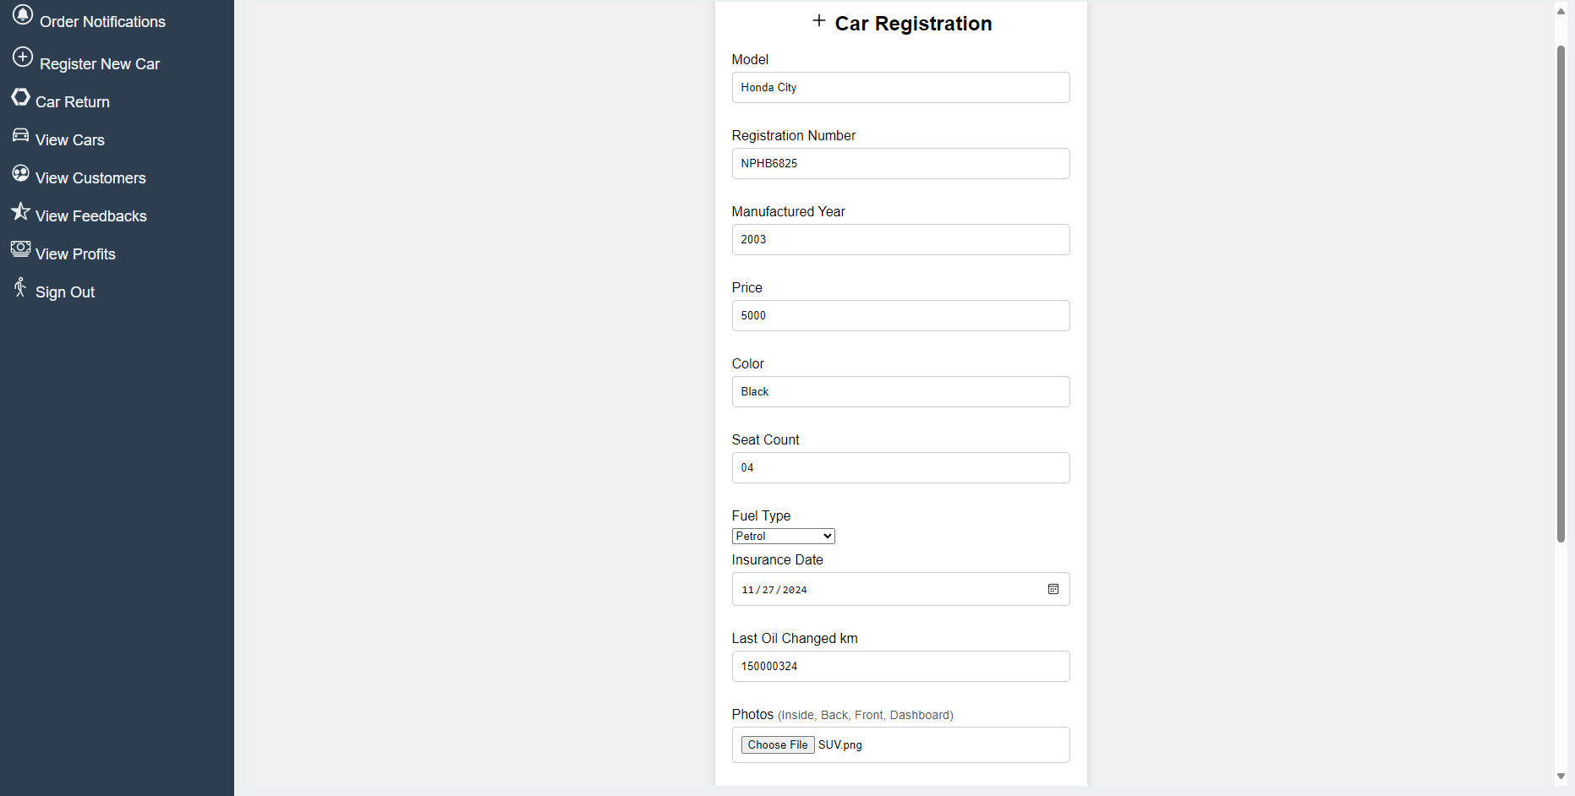

Add New Car Here…!

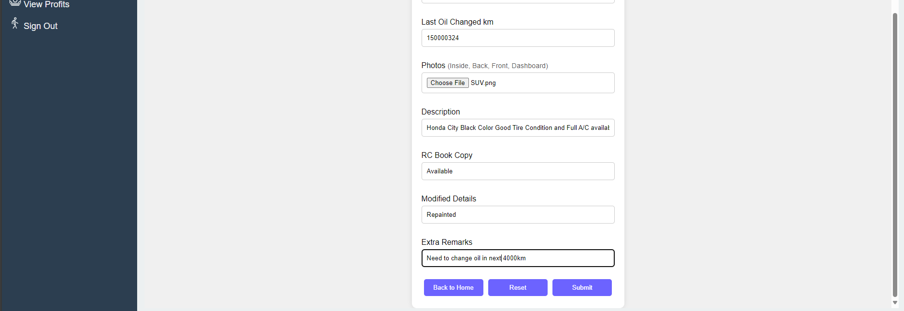

After register cars the page will be redirect to Car list for Admin view page

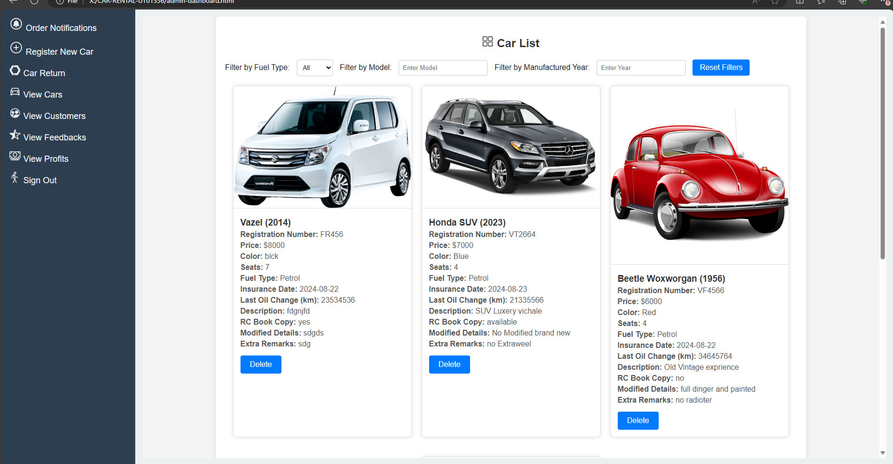

Click View Customers for View Users

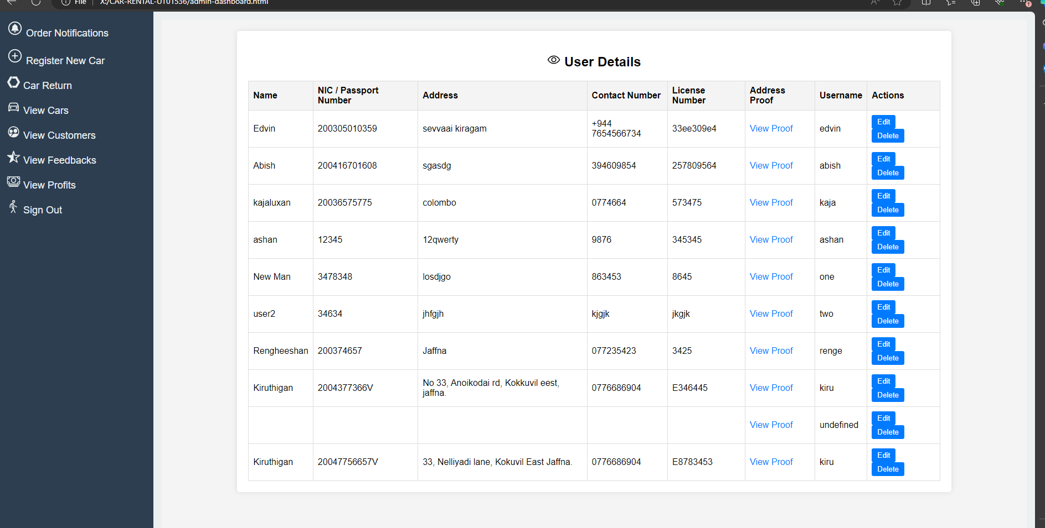

Can Delete User Here. Edit Button Not Work for time

Click on Car Return Tab

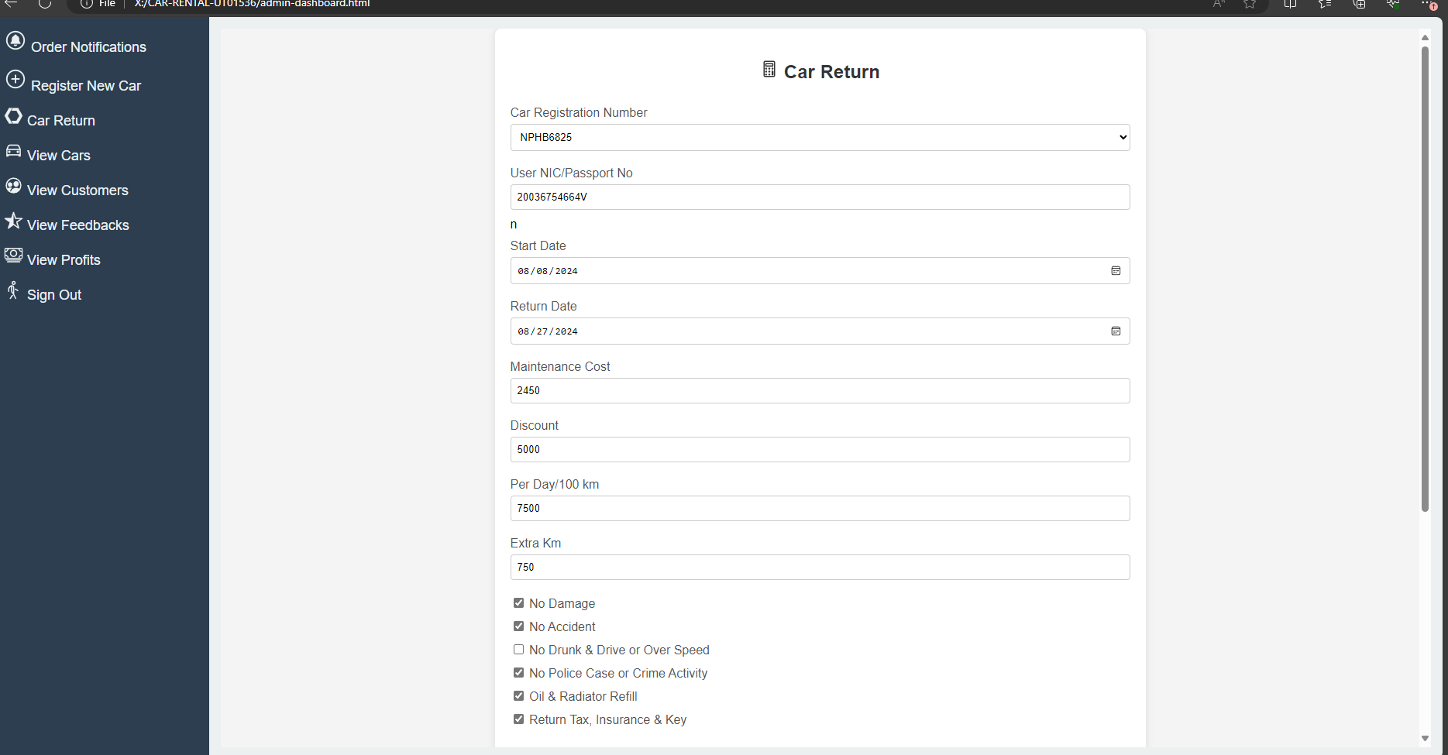

Select Car Number Plate drop down

Then Enter Customer NIC/Passport Number and

Start Date, Return Date, Maintenance Cost, Discount, Per Day/100 km, Extra Km Details also click check list for Verify return car direct inception by admin.

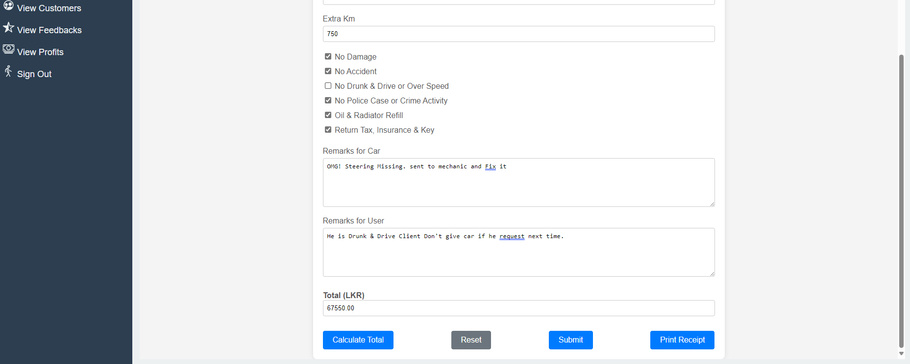

Can Add Remarks for Car and Client and if click calculate total final amount will show here,

If click Print Receipt we can print hard copy if client asked for their company billing purpose.

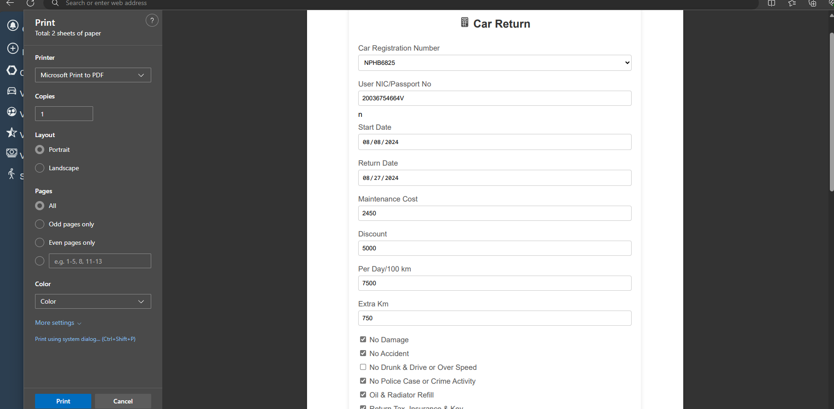

Then click submit and Can view

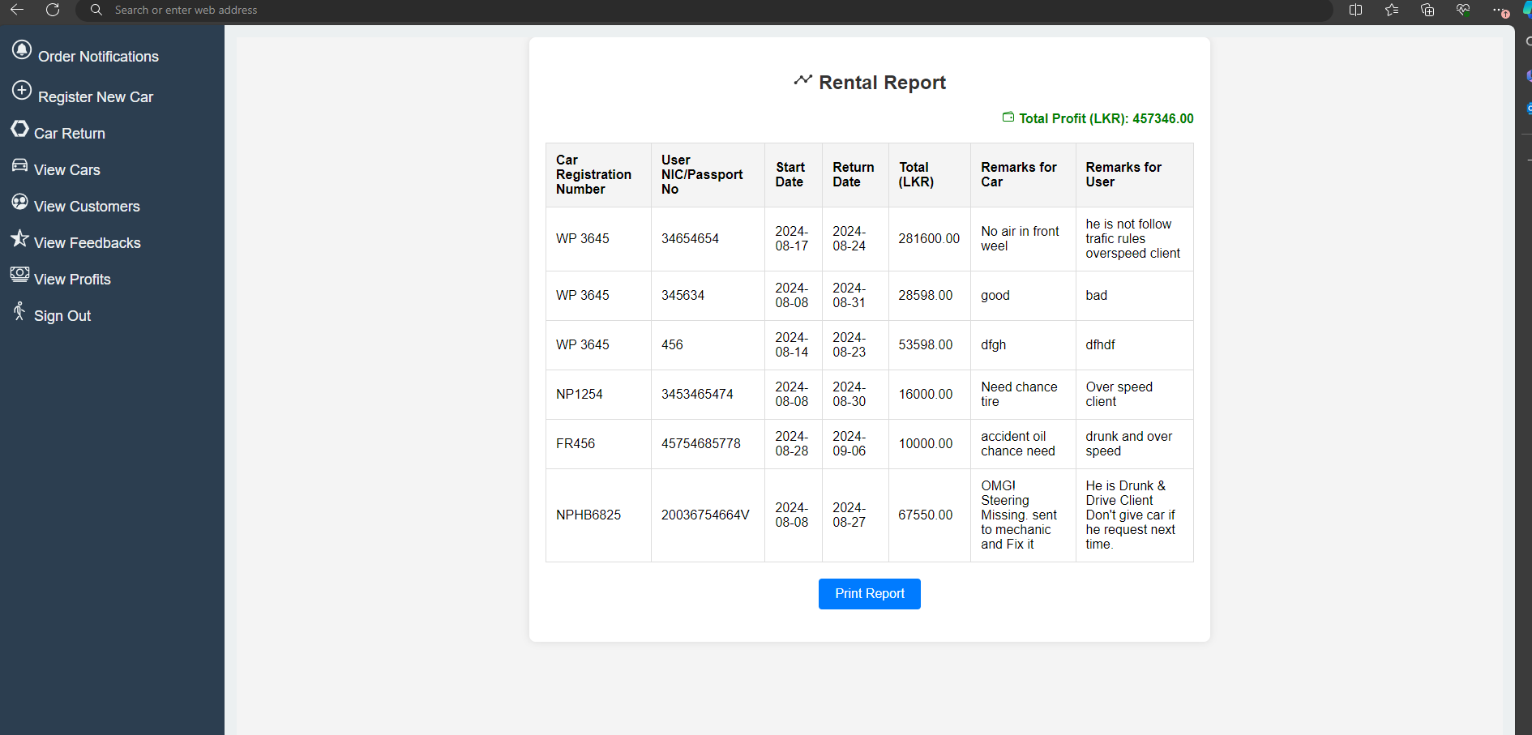

Can view the Cars, User Remarks given by admin here and Total Income of Car Management System service.

If click Sign out the page will redirect to Admin login page.

Thank you.

UT01536 Kiruthigan.